CSA-0717

Lab Experiments: 6-10

1. Design and Configuration of Tree Topologies using Packet Tracer.

Tree Topology using Hub:

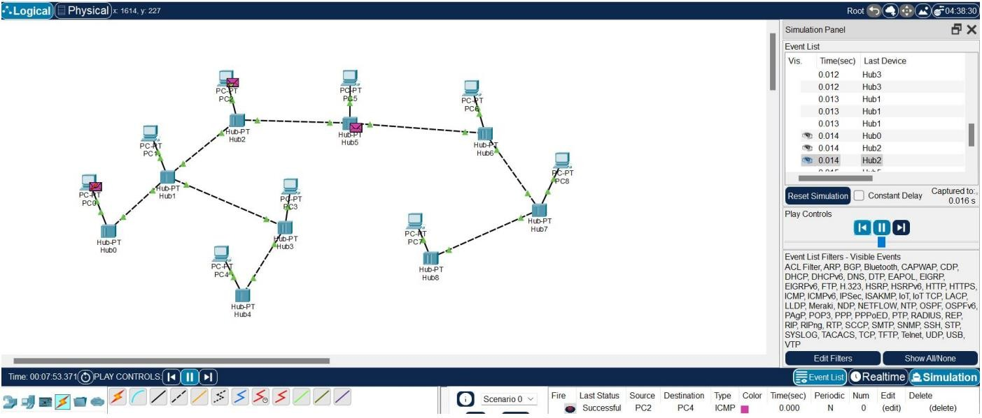

Tree Topology using Switch:

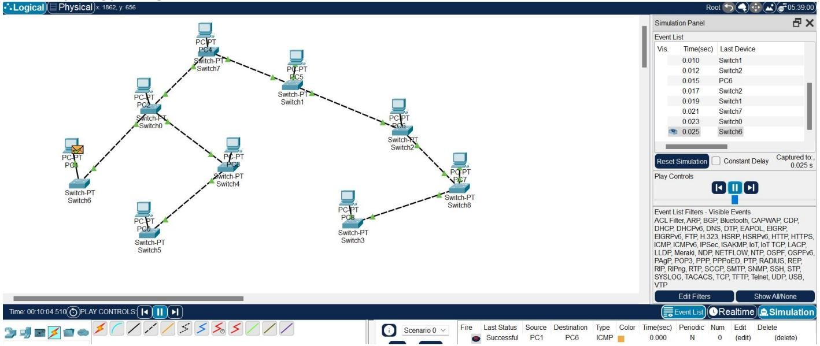

1. Design and Configuration of Hybrid Topologies using Packet Tracer

Hybrid Topology using Hub:

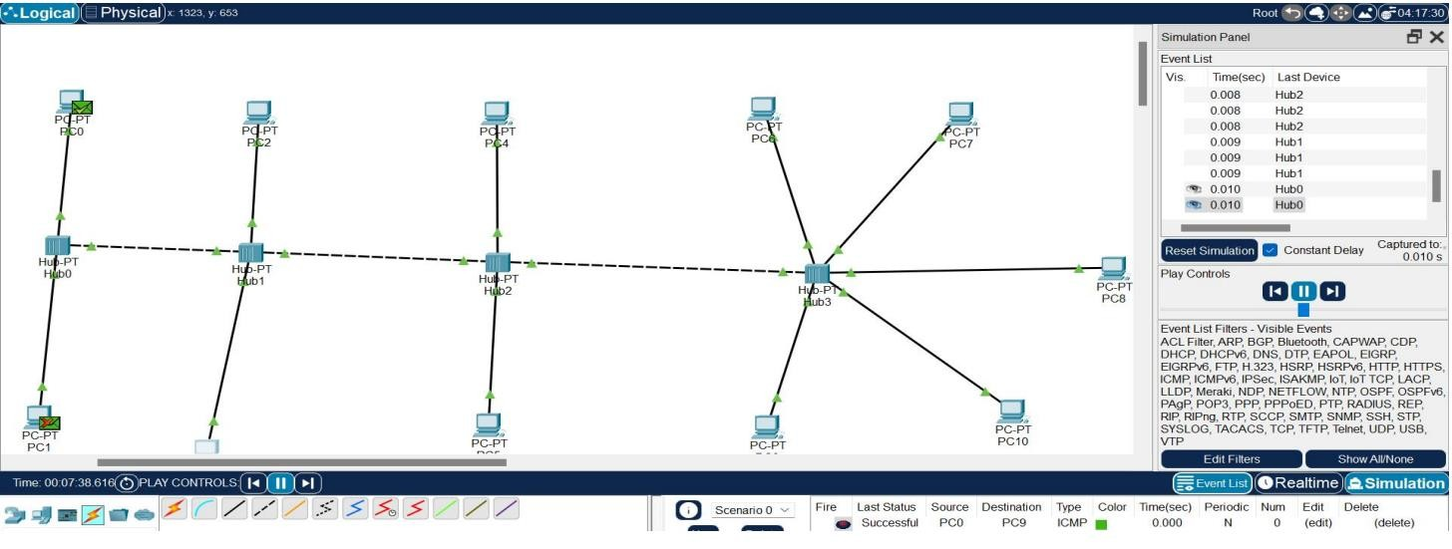

Hybrid Topology using Switch:

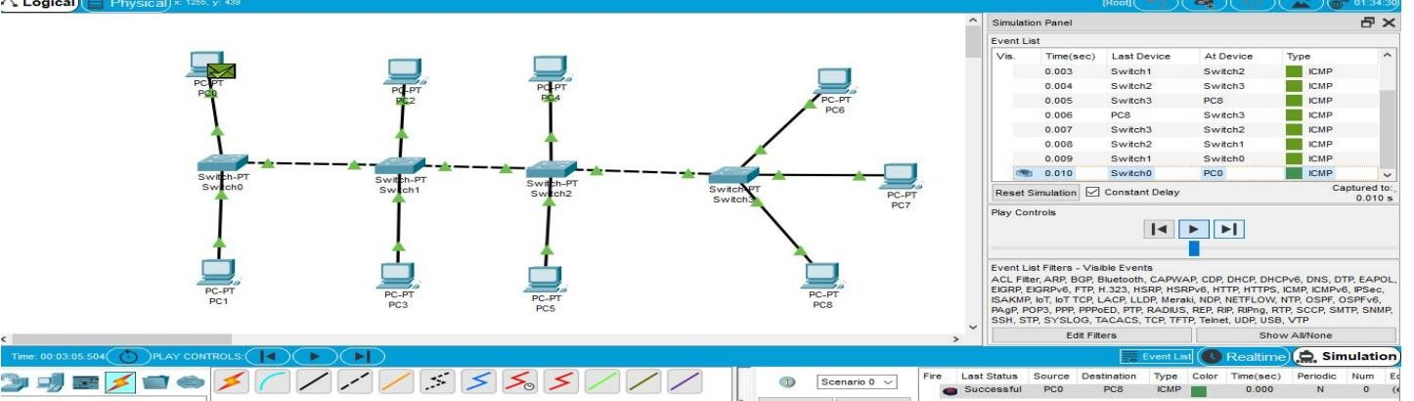

1. Data Link Layer Traffic Simulation using Packet Tracer Analysis of ARP

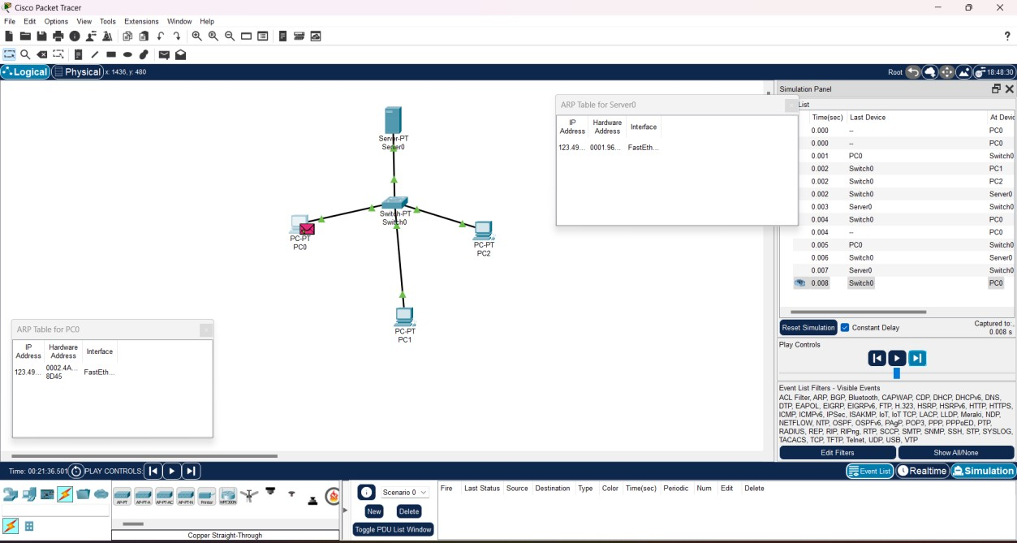

1. Data Link Layer Traffic Simulation using Packet Tracer Analysis of LLDP

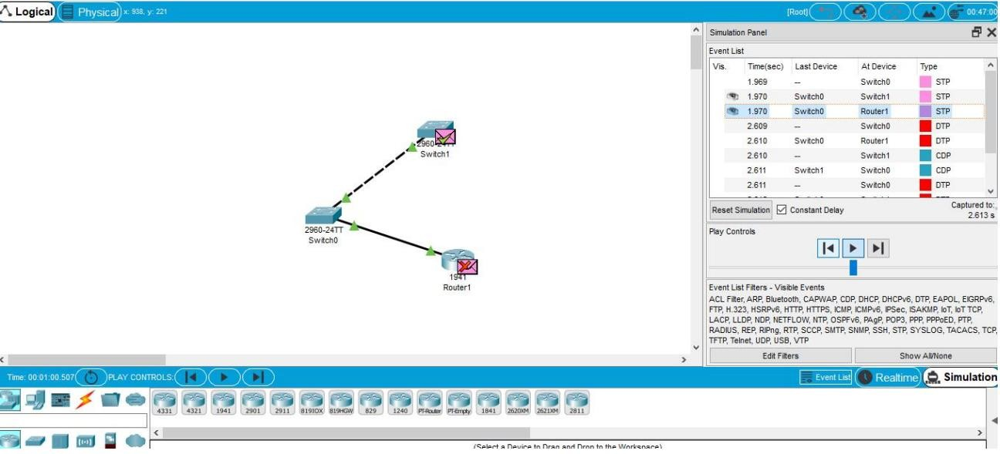

1. Data Link Layer Traffic Simulation using Packet Tracer Analysis of CSMA/CD & CSMA/CA

